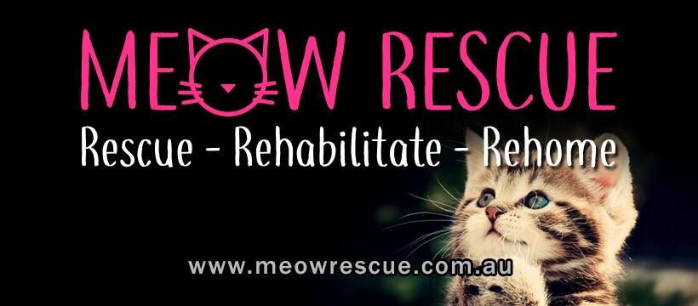
Foster Care Application & Agreement
Applicant Details
First Name:
Surname:
DOB:
Mobile Phone:
Email:
Drivers Licence Number:
Address:

Renting or owned home?:
Employment- Full Time/Part Time?:
Number of Adults and Children at home plus ages? :

Number of animals & species? Are they desexed and vaccinated?

Have you fostered before and with which rescue group?
--

My services are provided strictly in a voluntary capacity as a volunteer, and without any express or implied promise of salary, compensation or other payment of any kind whatsoever.
My services are furnished without any employment-type benefits, including employment insurance programs, worker’s compensation accrual in any form, holiday or sick leave.
I understand that Meow Rescue may terminate my services as a volunteer at any time at its discretion.
I understand that my role is solely as a temporary home for a foster pet, and that
although my opinion regarding the match between the foster pet and potential adopters is very important given my relationship with and knowledge of my foster pet, the ultimate placement of any pets I foster will be conducted by Meow Rescue. It is Meow Rescue responsibility to review, interview and ultimately approve potential adopters.
Accordingly, I acknowledge that any foster pet is the property of Meow Rescue and I will return the foster pet to Meow Rescue if I am requested to do so.
I fully understand that Meow Rescue expects high standards of moral and ethical treatment of the animals under its care. I will adhere strictly to these standards in my capacity as a volunteer.
I will remember in all my dealings with the public as a foster volunteer that that members of the public will consider my words and actions to be representative of the attitudes and positions of Meow Rescue as an organisation. I understand that as an individual, I am not authorised to speak for Meow Rescue, nor can I enter into any agreements on behalf of Lou’s Kitten Rescue.
I understand that I am personally responsible for any and all financial expenses that I incur while fostering pets for Meow Rescue unless otherwise agreed in writing. Although Meow Rescue may reimburse my expenses, I agree that each expense must be supported by receipts and must be pre-approved by my Foster Program contact/representative. I accept full responsibility for any expenses incurred by me that fall outside of approved expenditures.
I agree to not leave a Meow Rescue foster pet in anyone else’s care unless that person is pre-approved by the Foster Program contact/representative of Meow Rescue.
I understand that Meow Rescue cannot guarantee or be held responsible for the temperament, behaviour, or health of foster pets that I may handle. I am aware that foster pets may cause damage to my personal property, other pets, and humans.
I will keep cats securely housed at all times while in my care.
I agree to a home inspection at the request of Meow Rescue or a representative.
I understand that the handling of animals and other volunteer activities may place me in a hazardous situation and could result in injury to me or my personal property. On behalf of myself, and my heirs’ personal representatives and assigns, I hereby release, discharge, indemnify and hold harmless Meow Rescue and its representatives from any and all claims, causes of action and demands of any nature, whether known or unknown, arising out of or in connection with my volunteer activities.
I understand that public relations is an important part of a volunteer’s activities, I hereby authorise Meow Rescue to use any photographs of me in its possession for public relations purposes.
Declaration
By signing below, I hereby accept a position as a volunteer foster carer for Meow Rescue, upon the above terms, conditions and understandings.
I hereby acknowledge the above terms and conditions and agree to abide by them during the entire time I am fostering pets for Meow Rescue.
I also acknowledge that this Agreement, combined with any previously signed Foster Care Application, forms the basis of my relationship with Meow Rescue in a volunteer capacity.

Signed (applicant): _____________________________________________________
Print name: ___________________________________________________________
Date: ________________________________________________________________

Signed (organisation): ___________________________________________________
Print name: ___________________________________________________________
Date: _______________________________________________________

